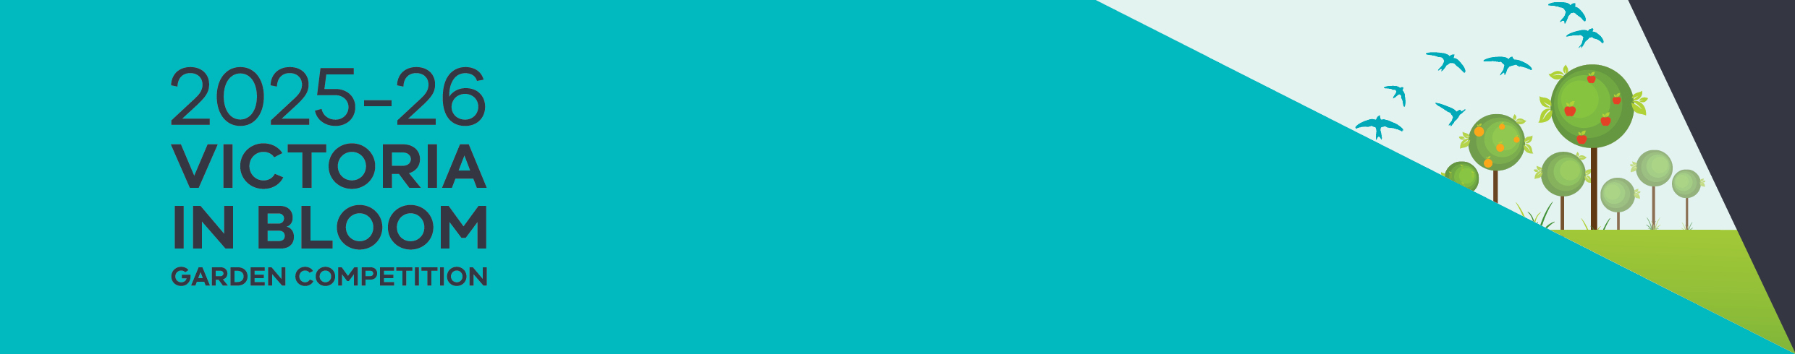

Registration form – for renters

# About Victoria in Bloom

Victoria in Bloom is a gardening competition for anyone living in public or community housing in Victoria.

The competition recognises and rewards gardeners who are actively creating and maintaining gardens on their properties or in shared communal areas.

Any type or size of garden can be entered – from backyard gardens to balcony and community gardens.

## Instructions

To enter the competition:

* Fill in this form and save it – otherwise, you will lose your changes
* Email the form [email the Victoria in Bloom program manager vicbloom@dffh.vic.gov.au](mailto:vicbloom@dffh.vic.gov.au)

Alternatively, you can call **8633 4357** and enter over the phone.

## Privacy

The Department of Families, Fairness and Housing is committed to protecting your privacy. We collect and handle the personal information that you provide on this Victoria in Bloom Application form for the purpose of contacting you to take photos of your garden, assess your entry in the competition and to let you know about the competition outcome. If you don’t provide the information required by this form, we may not be able to process your entry into the competition.

The department will only use your information in accordance with relevant privacy and other laws. You can request access to your personal information by contacting the Freedom of Information Unit:

Phone: (03) 90968449

[Email the Freedom of Information Unit](mailto:foi@dffh.vic.gov.au) foi@dffh.vic.gov.au.

|  |
| --- |
| To receive this document in an accessible format, phone **8633 4357**, using the National Relay Service 13 36 77 if required, or [email the Victoria in Bloom program manager](mailto:vicbloom@dffh.vic.gov.au) vicbloom@dffh.vic.gov.au.  Authorised and published by the Victorian Government, 1 Treasury Place, Melbourne. © State of Victoria, Australia, Department of Family, Fairness and Housing, March 2025. Available on the [Housing website](http://www.housing.vic.gov.au/vicinbloom) www.housing.vic.gov.au/vicinbloom |

# Entry form

Send the completed form by [email to Victoria in Bloom coordinator](mailto:vicbloom@dffh.vic.gov.au) vicbloom@dffh.vic.gov.au by 21 November 2025.

## Personal details

| Detail | Response |
| --- | --- |
| Name |  |
| Address |  |
| Email address |  |
| Local government area |  |
| Telephone |  |

## Housing type

| Type of housing you live in | Choose (Mark with x) |
| --- | --- |
| Public housing |  |
| Community housing |  |

## Community housing manager

If you live in community housing, and if you know, tell us which organisation manages your housing.

| My community housing manager |
| --- |
|  |

## Competition category

Which category are you entering? You can choose up to two categories.

| Category | Choose (Mark with x) |
| --- | --- |
| Best Balcony or Container Garden |  |
| Best Small Enclosed Garden |  |
| Best Young Gardener (under 25) |  |
| Best Household Garden |  |
| Best Sustainable Garden |  |
| Best Community or Common Area Garden |  |
| Best Edible Garden |  |
| Best Creative Garden |  |
| Best First Year Entered Garden |  |