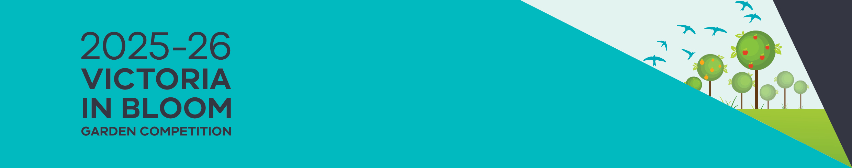

Enter your garden now!

Your garden, your story

Victoria in Bloom is a gardening competition for anyone living in public or community housing in Victoria. The competition recognises and rewards gardeners who are actively creating and maintaining gardens on their properties or in shared communal areas.

# Who can enter the competition?

Anyone living in public or community housing in Victoria can enter.

## What types of gardens can be entered?

Any type or size of garden can be entered – from backyard gardens to balconies and community gardens.

## What are the award categories?

The 2025–26 Victoria in Bloom garden competition has nine award categories. You can enter your garden in up to two of these:

|  |  |
| --- | --- |
| Category | Description |
| Best Balcony or Container Garden | Gardens which are on a balcony space, or gardens made up of potted plants. |
| Best Small Enclosed Garden | Gardens that are enclosed, such as courtyards. |
| Best Young Gardener (under 25) | To enter this category, young gardeners must play an active role in gardening – either at home, or in a community or school garden. |
| Best Household Garden | Front or back gardens are larger than a courtyard. |
| Best Sustainable Garden | These gardens focus on being environmentally sustainable. They may include features like compost, water tanks, worm farms, mulch and drought-tolerant plants. Often commercial pesticides are not used. |
| Best Community or Common Area Garden | These gardens are in common areas and shared by a group of people, meaning they can be accessed and used by all the residents on a property. They are often part of an apartment or unit complex. |
| Best Edible Garden | Gardens where most of the plants are fruit, vegetable and/or herbs. |
| Best Creative Garden | Garden that has been designed using creativity, uniqueness and self-expression. |
| Best First Year Entered Garden | Garden entered for the first time in the competition. |

## How do I enter?

You need to register your garden in one of the following ways:

Call: 8633 4357 or 8633 4362

[Email the Victoria in Bloom program manager](mailto:vicbloom@dffh.vic.gov.au) vicbloom@dffh.vic.gov.au.

When you register, you will need to tell us your:

* Name, address and telephone
* email address (if you have one)
* the award category you would like to enter (you can enter your garden in up to two categories).
* Any information you provide the department will be kept confidential in accordance with the relevant privacy laws.

## How long do I have to register?

Registrations close on 21 November 2025.

## What happens after I register?

An entry pack with more information and some gardening goodies will be mailed out to you.

A departmental staff member will contact you to request photos via email/or phone. If you don’t have an email or phone, a staff member will arrange a time to visit if you to take the photos.

During the phone call or home visit, we will collect information describing your garden.

The information we collect will be used by us to complete your garden entry.

## How is the competition judged?

We judge the competition in two stages – first by division (North, East, South, and West) and then state-wide.

Winners in each division go on to be finalists in their category for the state-wide competition.

## Questions?

Call the Department of Families, Fairness and Housing at **8633 4357/8633 4362** or [email the Victoria in Bloom program manager](mailto:vicbloom@dffh.vic.gov.au)  vicbloom@dffh.vic.gov.au.

For more information about Victoria in Bloom, visit the [Housing website](http://www.housing.vic.gov.au/vicinbloom) www.housing.vic.gov.au/vicinbloom.

|  |
| --- |
| To receive this document in an accessible format, phone **8633 4357**, using the National Relay Service 13 36 77 if required, or [email the Victoria in Bloom program manager](mailto:vicbloom@dffh.vic.gov.au)  vicbloom@dffh.vic.gov.au.  Authorised and published by the Victorian Government, 1 Treasury Place, Melbourne. © State of Victoria, Australia, Department of Families, Fairness and Housing, March 2025. Available on the [Housing website](http://www.housing.vic.gov.au/vicinbloom) www.housing.vic.gov.au/vicinbloom |