

|  |
| --- |
| Steps to update your household income information through HousingVic Online Services |
| February |

If you are a public housing renter, you can view and update your household tenancy information with ease by linking HousingVic Online Services to your myGov account. This includes removing a household member and/or updating your household’s income and asset information.

Once submitted, these updates can help support any rental rebate application assessment.

You have a choice to either select to

1. update the department with changes to your household’s income and asset information and/or
2. remove a household member from your tenancy

### Update income and asset information

To update your household information, please follow these steps:

1. sign in to myGov

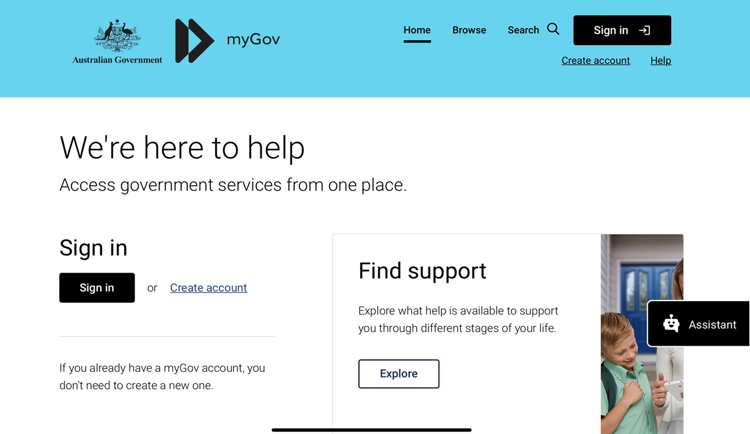

1. select HousingVic Online Services

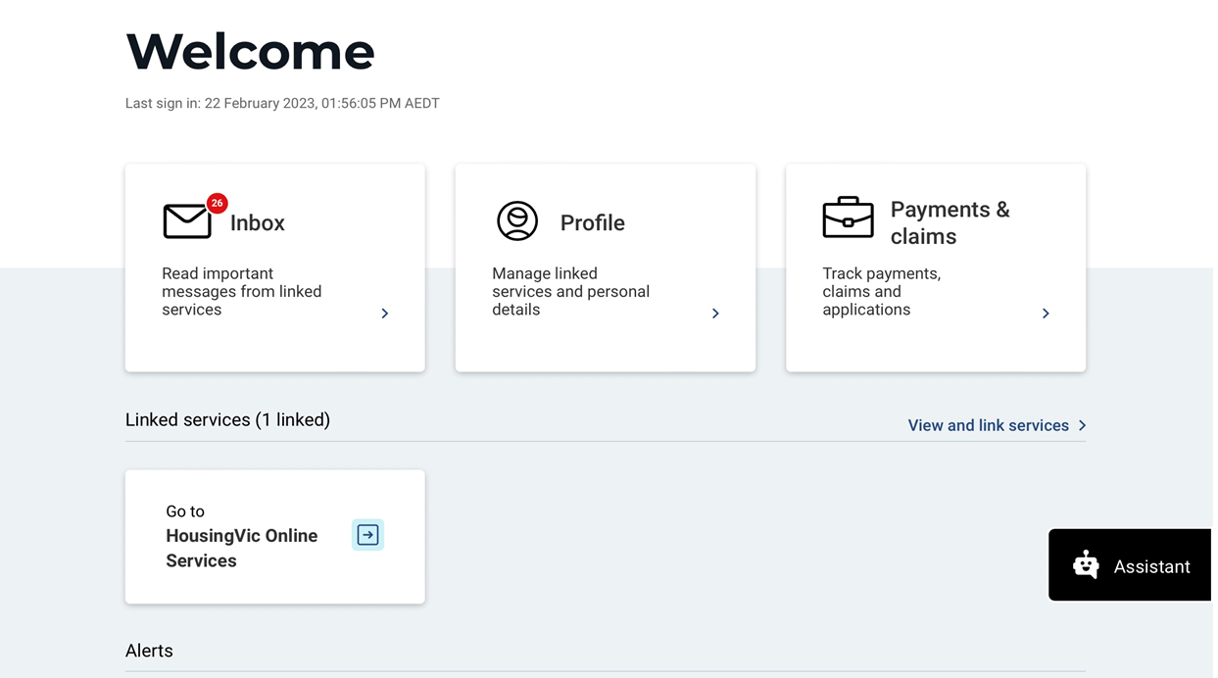

1. close the privacy pop up (if you see it)

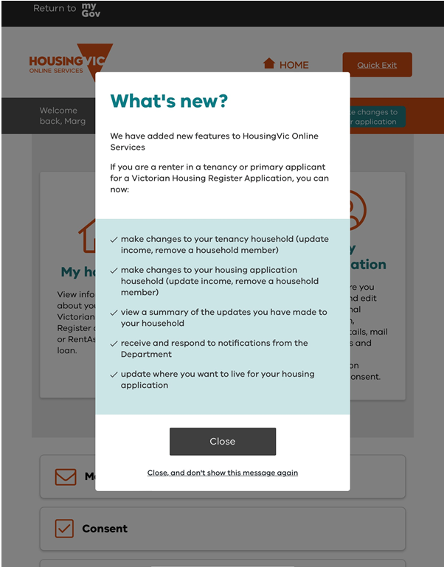

1. select the ‘My Housing’ tile

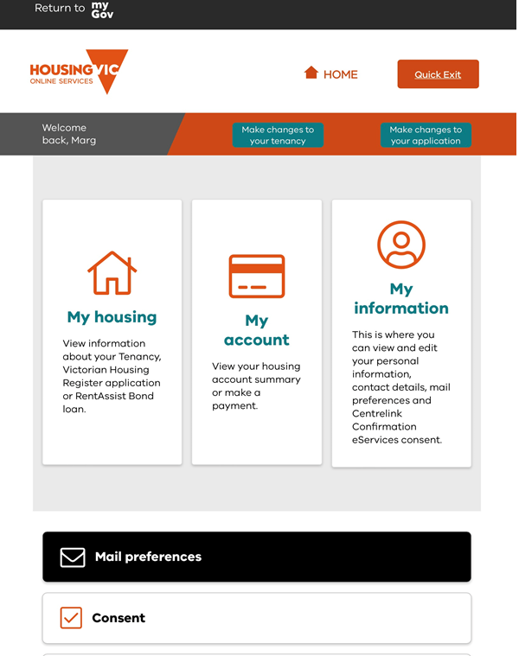

1. select the ‘tenancy’ tile

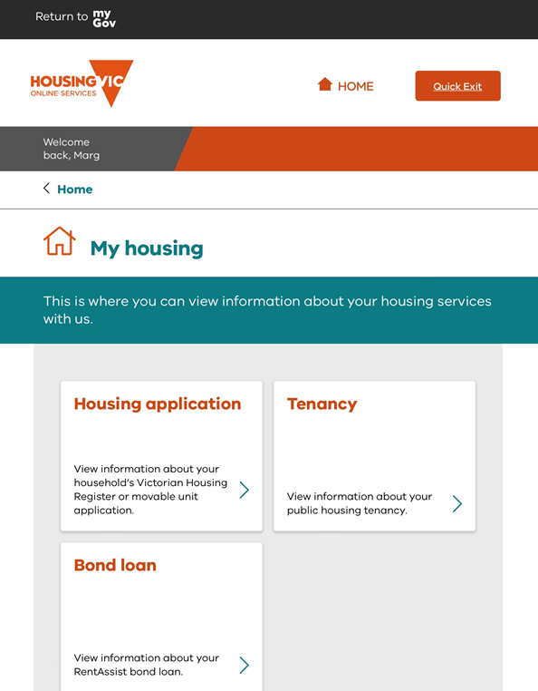

1. select the correct address

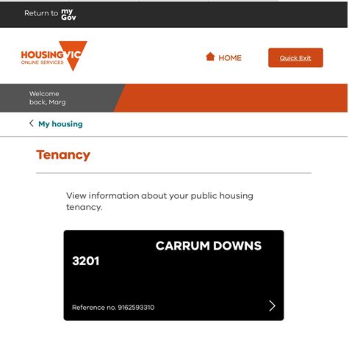

1. scroll down until you see the button ‘make changes to your household’

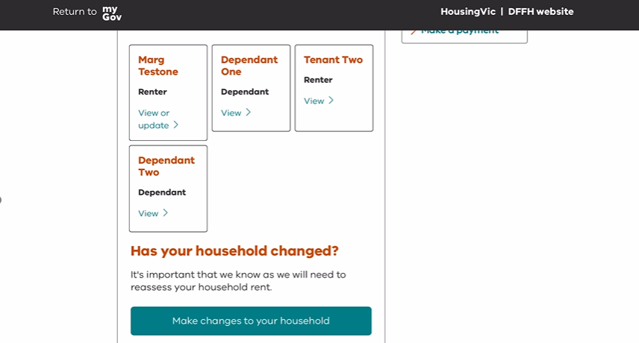

1. you don’t need to do anything on this screen except select ‘Save and continue’ button

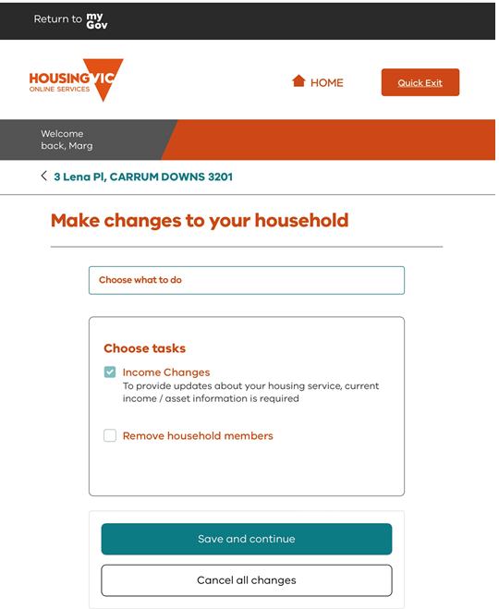

1. select ‘Save and continue’ once you have read what you will need

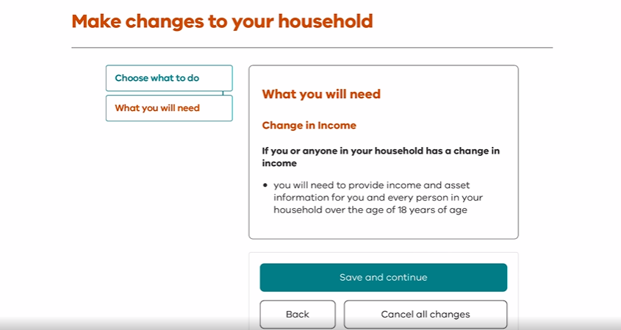

1. upload documents for all household members

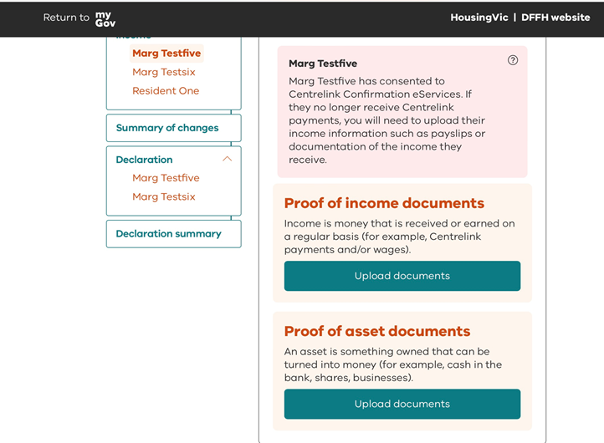

1. view the summary of changes screen and if everything is okay, select ‘Save and continue’

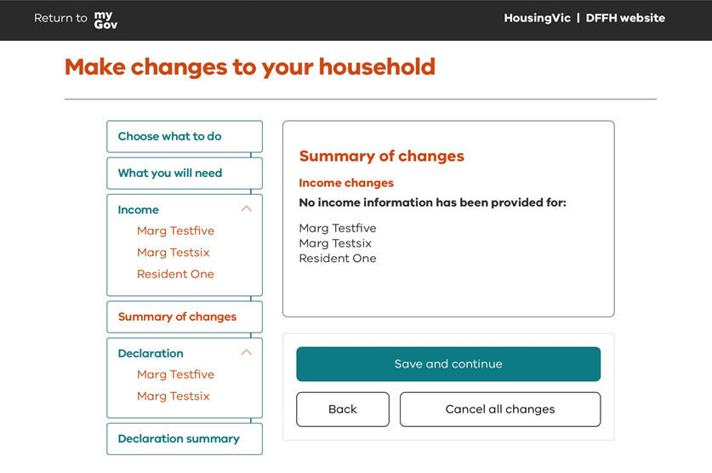

1. each renter will need to agree to the declaration checkboxes. If you have another renter living with you, they can sign in to their own myGov account, register for HousingVic Online Services and follow the steps above. When they get to the declaration screen, they will be able to declare online by checking the checkboxes

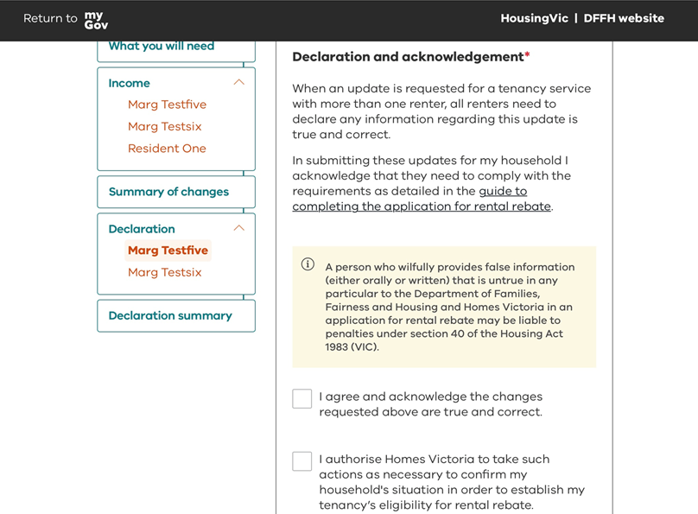

1. when you are happy with your request and all the documents you have uploaded, select ‘Submit’

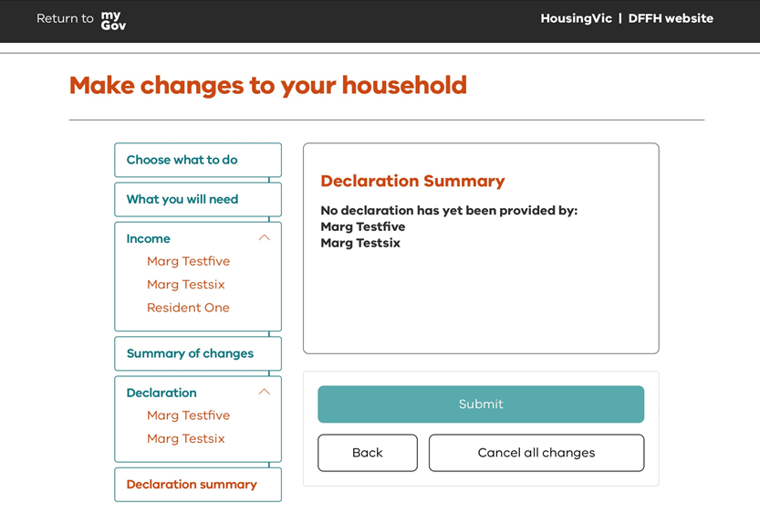

1. you can then see a brief history of what you have submitted

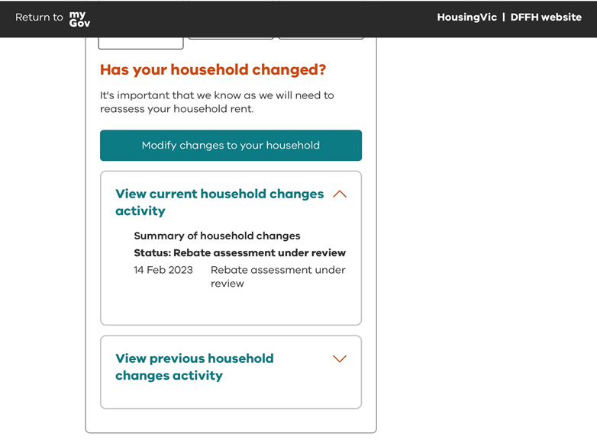

|  |
| --- |
| To receive this document in another format, [email HousingVic Online Services](mailto:hvos@dffh.vic.gov.au) <hvos@dffh.vic.gov.au>.  Authorised and published by the Victorian Government, 1 Treasury Place, Melbourne.  © State of Victoria, Australia, Department of Families, Fairness and Housing, Feb 2023.  Except where otherwise indicated, the images in this document show models and illustrative settings only, and do not necessarily depict actual services, facilities, or recipients of services.  Available at [Housing Vic](https://www.housing.vic.gov.au/online-services) < https://www.housing.vic.gov.au/online-services. |