

| Additional bond loan applicants |  |
| --- | --- |
| (for use with the Application for a bond loan) |  |

Use black or blue pen, use CAPITAL letters and mark boxes with an X.

# Documents we need with this application

Listed below are documents that you and everyone who will live with you may need to give us to confirm your **general eligibility** for a bond loan.

 As you fill in the form, you will see a symbol of a piece of paper with a paperclip. It is there to tell you what other documents you may need to give us in some situations.

# OFFICE USE ONLY

|  |  |
| --- | --- |
| Date received |  |
| Received by |  |
| Date registered |  |
| Bond reference number |  |
| Name of bond agency |  |

| Evidence | Yes or No |
| --- | --- |
| Income proof confirmed and attached |  |
| ID proof confirmed and attached |  |
| Landlord section completed |  |

# Section F – Other applicants who are applying for a bond loan

This section should be completed for other members of your household who are applying for a bond loan. Do not include details of dependants here, except where asked.

## F5 About household applicant 4

In this section we will ask for information about other household members applying for bond assistance

Questions with an (*) must be answered

### F5.1 Title

| Title | Mark with X |
| --- | --- |
| **Mr** |  |
| **Miss** |  |
| **Ms** |  |
| **Mrs** |  |
| **Dr** |  |
| **Prof** |  |
| **Other** |  |

### F5.2 Their name (as it appears on official documents)

|  |  |
| --- | --- |
| ****First name**** |  |
| ****Middle name**** |  |
| ****Family name**** |  |
| Previous name (if any)  (For example, name at birth, maiden name, previous married name, alias) |  |
| ****Preferred name**** |  |

 **Proof of identity documents**. See ‘Proof of identity’ on page 4 of the Application for RentAssist bond loan for further information.

### F5.3 Date of birth

|  |  |
| --- | --- |
| Date of birth |  |

**F5.4**  Gender

| Gender | Mark with X |
| --- | --- |
| **Male** |  |
| **Female** |  |
| **Indeterminate** |  |
| **Intersex** |  |
| **Other** |  |

### F5.5 Marital status

| Status | Mark with X |
| --- | --- |
| **Single** |  |
| **Partnered** |  |
| **Married** |  |

### F5.6 Country of birth

| Country |  |
| --- | --- |

### F5.7 What is their residency status?

| Status | Mark with X |
| --- | --- |
| Australian citizen – **Go to F5.11** |  |
| Permanent resident |  |
| New Zealand resident |  |
| Sponsored migrant |  |
| Permanent protection visa |  |
| Resolution of status visa |  |
| Visa subclass (if applicable) |  |

|  |  |
| --- | --- |
| Visa subclass number |  |

### F5.8 When did they start living in Australia?

|  |  |
| --- | --- |
| Date |  |

### F5.9 Are they affected by Centrelink’s two-year newly-arrived residents waiting period?

| Option | Mark with X |
| --- | --- |
| **No** |  |
| **Yes** |  |

|  |  |
| --- | --- |
| If yes, tell us the expiry date |  |

### F5.10 Did they migrate to Australia under an Assurance of support?

| Option | Mark with X |
| --- | --- |
| **No** |  |
| **Yes** |  |
| If yes, tell us the expiry date | | |  |

### F5.11 Aboriginal or Torres Strait Islander?

| Response | Mark with X |
| --- | --- |
| **No** |  |
| **Aboriginal** |  |
| **Torres Strait Islander** |  |
| **Both** |  |

### F5.12 Do they have any dependent children?

| Option | Mark with X |
| --- | --- |
| Yes |  |
| No |  |

| Number of dependants |  |
| --- | --- |

## F6 About household applicant 5

## Applicant details

### F6.1 Title

| Title | Mark with X |
| --- | --- |
| **Mr** |  |
| **Miss** |  |
| **Ms** |  |
| **Mrs** |  |
| **Dr** |  |
| **Prof** |  |
| **Other** |  |

### F6.2 Their name (as it appears on official documents)

|  |  |
| --- | --- |
| ****First name**** |  |
| ****Middle name**** |  |
| ****Family name**** |  |
| Previous name (if any)  (For example, name at birth, maiden name, previous married name, alias) |  |

|  |  |
| --- | --- |
| ****Preferred name**** |  |

 **Proof of identity documents**. See ‘Proof of identity’ on page 4 for further information.

### F6.3 Date of birth

|  |  |
| --- | --- |
| Date of birth |  |

**F6.4**  Gender

| Gender | Mark with X |
| --- | --- |
| **Male** |  |
| **Female** |  |
| **Indeterminate** |  |
| **Intersex** |  |
| **Other** |  |

### F6.5 Marital status

| Status | Mark with X |
| --- | --- |
| **Single** |  |
| **Partnered** |  |
| **Married** |  |

### F6.6 Country of birth

| Country |  |
| --- | --- |

### F6.7 What is their residency status?

| Status | Mark with X |
| --- | --- |
| Australian citizen – **Go to F6.11** |  |
| Permanent resident |  |
| New Zealand resident |  |
| Sponsored migrant |  |
| Permanent protection visa |  |
| Resolution of status visa |  |
| Visa subclass (if applicable) |  |

|  |  |
| --- | --- |
| Visa subclass number |  |

### F6.8 When did they start living in Australia?

|  |  |
| --- | --- |
| Date |  |

### F6.9 Are they affected by Centrelink’s two-year newly-arrived residents waiting period?

| Option | Mark with X |
| --- | --- |
| **No** |  |
| **Yes** |  |

|  |  |
| --- | --- |
| If yes, tell us the expiry date |  |
|  |  |

### F6.10 Did they migrate to Australia under an Assurance of support?

| Option | Mark with X |
| --- | --- |
| **No** |  |
| **Yes** |  |

|  |  |
| --- | --- |
| If yes, tell us the expiry date |  |

### F6.11 Aboriginal or Torres Strait Islander?

| Response | Mark with X |
| --- | --- |
| **No** |  |
| **Aboriginal** |  |
| **Torres Strait Islander** |  |
| **Both** |  |

### F6.12 Do they have any dependent children?

| Option | Mark with X |
| --- | --- |
| Yes |  |
| No |  |

| Number of dependants |  |
| --- | --- |

# F7 Income and Assets of applicant 4

## F7.1 Please select the income types they are receiving

| Option | Mark with X |
| --- | --- |
| **Centrelink Payments** |  |
| **Department of Veterans’ Affairs (DVA) payments** |  |
| **Self employed** |  |
| **Paying job** |  |
| **None** |  |
| **Other** |  |
| **If other please advise** | |

### F7.2 Please provide Centrelink Reference Number (CRN) Number

|  |  |
| --- | --- |
| ****CRN**** |  |

### F7.3 Do you consent to income confirmation?

| Option | Mark with X |
| --- | --- |
| **No Go to F7.4** |  |
| **Yes Sign the Consent to use CCeS in** Section I**, and go to F7.5** |  |

Paper clip on paper - document/s required. **Proof of income documents**. See ‘Proof of income’ on page 4 of the application for RentAssist bond loan.

# F7.4 Assets

### What is an asset?

An asset is something you own that can be turned into money — like shares, businesses, mobile homes and any cash you have in the bank.

If they are expecting to receive a payout from an organisation like WorkSafe or the Transport Accident Commission (TAC), please add it here.

| Asset type | Value | Can the asset be cashed in or sold?  Write ‘Yes’ or ‘No’ |
| --- | --- | --- |
|  | $ |  |
|  | $ |  |
|  | $ |  |
|  | $ |  |
|  | $ |  |
|  | $ |  |

Paper clip on paper - document/s required. **You will need to attach a document confirming ownership/existence of this asset.**. See proof of assets on page 4 on the Application for RentAssist bond loan for further information.

### F7.5 Do they own or part-own any real estate?

| Option | Mark with X |
| --- | --- |
| **No** |  |
| **Yes** |  |

|  |  |
| --- | --- |
| Property address |  |
| Suburb or town |  |
| State |  |
| Postcode |  |
| Real estate or Land value $ |  |

### Are they able to live in the property (mentioned above) permanently?

| Option | Mark with X |
| --- | --- |
| **No** |  |
| **Yes** |  |

You will need to attach one or more of the following:

Letter from approved valuer or solicitor stating the property’s market value and your equity in it.

If the property is part owned, we need information about your share

If the property is held in trust, we need a letter from the executor of the estate

Attach a document that details your interest in the property and why you are unable to occupy it

### Can this real estate or land be sold?

| Option | Mark with X |
| --- | --- |
| **No** |  |
| **Yes** |  |

### Is the property for sale?

| Option | Mark with X |
| --- | --- |
| **No** |  |
| **Yes** |  |

You will need to attach a document from the real estate agent confirming this

### If the answer is no to any of the questions above, tell us why

|  |
| --- |
|  |

### If the property subject to a dispute or an application for settlement in the Family Court?

| Option | Mark with X |
| --- | --- |
| **No** |  |
| **Yes** |  |

You will need to attach a document from a solicitor confirming this

### Tell us the reason

|  |
| --- |
|  |

Paper clip on paper - document/s required. If they are unable to live in the property permanently, we need **documents that explain why**.

* If the property is for sale, we need a **document from the real estate agent** confirming this.
* If there is a dispute or application for settlement, we need a **document from your solicitor** including details of ownership.

#### F7.6 What is their role in the household?

| Role | Mark with X |
| --- | --- |
| **Single** |  |
| **Partnered** |  |

|  |  |
| --- | --- |
| Partner’s name |  |

#### F7.7 What is their share of the rent in the property you want to rent?

|  |  |
| --- | --- |
| Share of rent | $ |

#### F7.8 Do they have any dependent children who have not already been included on this form?

|  |  |
| --- | --- |
| Do they have any dependent children? |  |
| Number of dependants |  |

# F8 Income and Assets of Household applicant 5

## F8.1 Please select the income types they are receiving

| Option | Mark with X |
| --- | --- |
| **Centrelink Payments** |  |
| **Department of Veterans’ Affairs (DVA) payments** |  |
| **Self employed** |  |
| **Paying job** |  |
| **None** |  |
| **Other** |  |
| **If other please advise** | |

### F8.2 Please provide Centrelink Reference Number (CRN) Number

|  |  |
| --- | --- |
| ****CRN**** |  |

### F8.3 Do they consent to income confirmation?

| Option | Mark with X |
| --- | --- |
| **No Go to F8.4** |  |
| **Yes Sign the Consent to use CCeS in** Section I**, and go to F8.5** |  |

Paper clip on paper - document/s required. **Proof of income documents**. See ‘Proof of income’ on page 4 for further information.

# F 8.4 Assets

### What is an asset?

An asset is something you own that can be turned into money — like shares, businesses, mobile homes and any cash you have in the bank.

If you are expecting to receive a payout from an organisation like WorkSafe or the Transport Accident Commission (TAC), please add it here.

| Asset type | Value | Can the asset be cashed in or sold?  Write ‘Yes’ or ‘No’ |
| --- | --- | --- |
|  | $ |  |
|  | $ |  |
|  | $ |  |
|  | $ |  |
|  | $ |  |
|  | $ |  |

Paper clip on paper - document/s required. **You will need to attach a document confirming ownership/existence of this asset.**. See proof of assets on page 4 of the Application for RentAssist bond loan for further information.

### F8.5 Do they own or part-own any real estate?

| Option | Mark with X |
| --- | --- |
| **No** |  |
| **Yes** |  |

|  |  |
| --- | --- |
| Property address |  |
| Suburb or town |  |
| State |  |
| Postcode |  |
| Real estate or Land value $ |  |

### Are they able to live in the property (mentioned above) permanently?

| Option | Mark with X |
| --- | --- |
| **No** |  |
| **Yes** |  |

You will need to attach one or more of the following:

Letter from approved valuer or solicitor stating the property’s market value and your equity in it.

If the property is part owned, we need information about your share

If the property is held in trust, we need a letter from the executor of the estate

Attach a document that details your interest in the property and why you are unable to occupy it

### Can this real estate or land be sold?

| Option | Mark with X |
| --- | --- |
| **No** |  |
| **Yes** |  |

### Is the property for sale?

| Option | Mark with X |
| --- | --- |
| **No** |  |
| **Yes** |  |

You will need to attach a document from the real estate agent confirming this

### If the answer is no to any of the questions above, tell us why

|  |
| --- |
|  |

### If the property subject to a dispute or an application for settlement in the Family Court?

| Option | Mark with X |
| --- | --- |
| **No** |  |
| **Yes** |  |

You will need to attach a document from a solicitor confirming this

### Tell us the reason

|  |
| --- |
|  |

Paper clip on paper - document/s required.

* If you are unable to live in the property permanently, we need **documents that explain why**.
* If the property is for sale, we need a **document from the real estate agent** confirming this.
* If there is a dispute or application for settlement, we need a **document from your solicitor** including details of ownership.

#### F8.6 What is their role in the household?

| Role | Mark with X |
| --- | --- |
| **Single** |  |
| **Partnered** |  |

|  |  |
| --- | --- |
| Partner’s name |  |

#### F8.7 What is their share of the rent in the property you want to rent?

|  |  |
| --- | --- |
| Share of rent | $ |

#### F8.8 Do they have any dependent children who have not already been included on this form?

|  |  |
| --- | --- |
| Do they have any dependent children? |  |
| Number of dependants |  |

# Section G – Current or previous assistance from the Department of Families, Fairness and Housing

## Social housing

### G1 Does anyone included in this application have a current application on the Victorian Housing Register?

| ****Response**** | Mark with X | ****Instructions**** |
| --- | --- | --- |
| **Yes** |  | **Go to G2** |
| **No** |  | **Go to G4** |

### G2 Do you wish to change the postal address for the application on the Victorian Housing Register?

| ****Response**** | Mark with X | ****Instructions**** |
| --- | --- | --- |
| **Yes** |  | **Go to G3** |
| **No** |  | **Go to G4** |

### G3 Current details of the application on the Victorian Housing Register

|  |  |
| --- | --- |
| Names of applicants |  |
| Service ID |  |

### G4 Has anyone included in this bond application received a bond loan from the department before?

| ****Response**** | Mark with X | ****Instructions**** |
| --- | --- | --- |
| **Yes** |  | **Go to G5** |
| **No** |  | **Go to Section H** |

### G5 Previous bond loan application

#### Primary applicant

|  |  |
| --- | --- |
| Full name |  |
| Property address |  |
| Suburb or town |  |
| State |  |
| Postcode |  |
| When did they apply? |  |

#### Has this loan been repaid?

| ****Response**** | Mark with X | ****Instructions**** |
| --- | --- | --- |
| **Yes** |  | **Go to Section H** |
| **No** |  | **Tell us why in the next table** |

|  |
| --- |
| If no, tell us why: |
|  |

# Section H Statutory declaration to be signed by all applicants

### Consent to be signed by all applicants

Before checking the box below, please read the following text:

A person who wilfully provides false information to the Department of Families, Fairness and Housing in order to obtain a bond loan may be liable for penalties under Section 40 of the *Housing Act 1983* (VIC). Furthermore, any person or persons making a false declaration are liable to the penalties of perjury under the *Evidence (Miscellaneous Provisions) Act 1958 (VIC)* which may include imprisonment.

### ****Household applicant 4****

|  |  |
| --- | --- |
| Full name |  |
| Of (current address) |  |
| Suburb or town |  |
| State |  |
| Postcode |  |

### ****Household appli****c****ant 5****

|  |  |
| --- | --- |
| Full name |  |
| Of (current address) |  |
| Suburb or town |  |
| State |  |
| Postcode |  |

To the Department of Families, Fairness and Housing, 50 Lonsdale Street, Melbourne 3000:

1. **I, ACKNOWLEDGE** that the bond money paid on my behalf to the estate agent or landlord is a loan advanced by the Director of Housing to me.
2. **I, ACKNOWLEDGE** that all applicants are jointly, individually or separately liable for any outstanding bond loan amount. This means that each applicant and all applicants together are liable for the whole bond debt as per the original bond loan agreement. If any part of the bond is legally withheld by the estate agent or landlord, the bond debt is equally divided amongst the household members. Before receiving a further bond loan, I may be required to sign an agreement to repay the remaining bond loan amount allocated to the other household members.
3. **I, AUTHORISE** the Department of Families, Fairness and Housing to issue a voucher payable to the Residential Tenancies Bond Authority, and undertake to provide this voucher to the estate agent or landlord together with the **covering letter and bond lodgement form** given to me by the Department of Families, Fairness and Housing.
4. **I, AGREE**

* to repay the loan immediately to the Department of Families, Fairness and Housing if the bond money is returned to me during or after my tenancy
* to return to the Department of Families, Fairness and Housing the voucher for the bond money if the tenancy of the rented premises does not proceed, and
* to participate in any legal proceedings for the recovery of the bond money.

1. **I, ACKNOWLEDGE** that I have understood the instructions and information given in this application.
2. **I, DECLARE** that to the best of my knowledge, all the information in this application for a bond loan has been provided, and that the information I have provided is true and correct.

**In Victoria and is declared by:**

|  |  |
| --- | --- |
| Print full name of Household applicant 4 |  |
| Signature of Household applicant 4 | **(Please sign by hand)** |

|  |  |
| --- | --- |
| Print full name of Household applicant 5 |  |
| Signature of Household applicant 5 | **(Please sign by hand)** |

## ****Witnessed before me****

**The authorised witness must print their name, address and title under section 107A of the *Evidence (Miscellaneous Provisions) Act 1958* (VIC) (as of 1 January 2010), (previously the *Evidence Act 1958* (VIC).**

**They may include a Justice of the Peace, police officer, court registrar, bank manager, medical practitioner, dentist or housing services officer.**

|  |  |
| --- | --- |
| Full name |  |
| Signature | **(Please sign by hand)** |
| Address |  |
| State |  |
| Postcode |  |
| Authorised title |  |
| Date |  |
| At |  |
| in Victoria |  |

# Section I – Centrelink Confirmation eServices (CCeS)

If you or any household member 18 years or over wish to use Centrelink Confirmation eServices (CCeS) to tell us about your income and assets, then please read the following information and sign the consent form.

CCeS is an online service that allows us to obtain information directly from Centrelink.

We recommend that you use CCeS if you are a Centrelink customer as we periodically require up-to-date information about your income and assets to confirm your eligibility for housing services.

CCeS has strict privacy and security standards. We must have your consent before we can obtain information about you from Centrelink.

You and your household members can provide consent by signing the **Consent to use CCeS** and marking the **Income confirmation** box with an X.

Once you have signed the consent form and marked ‘Income confirmation’ with an X, we can use CCeS to obtain information about your income and assets directly from Centrelink. This means you will not need to tell us about your income or assets (apart from lump sum payments). This will make it easier for you and quicker for us to assess your eligibility for housing services.

More [information about CCeS](https://www.humanservices.gov.au/individuals/services/centrelink/centrelink-confirmation-eservices) is available on Centrelink’s website <https://www.humanservices.gov.au/individuals/services/centrelink/centrelink-confirmation-eservices>.

## Consent to use Centrelink Confirmation eServices

**I/we** authorise the Australian Government Department of Human Services (Centrelink) to provide the Victorian Department of Families, Fairness and Housing (the department) with the results of the enquiries **I/we** have indicated below in order to enable the department to determine if **I/we** qualify for one or more of its housing services.

**I/we** understand that the information provided by Centrelink to the department may contain the following:

* **Income confirmation –** personal information such as (but not limited to)
  + - * + current or historical details of Centrelink payments received
        + dependants
        + marital or partnered status
        + Centrelink deductions
        + income from sources other than Centrelink
        + assets.

**I/we** authorise the department to use Centrelink Confirmation eServices to perform a Centrelink enquiry of **my/our** Centrelink income, asset and payment details.

**I/we** understand this consent, once signed, remains valid while **I am/we are** a customer/s of the department unless **I/we** revoke it by contacting the department or Centrelink.

**I/we** understand that if **I/we** withdraw **my/our** consent or do not alternatively provide proof of **my/our** circumstances or details, **I/we** may not be eligible for the service provided by the department.

### Household applicant 4

|  |  |  |
| --- | --- | --- |
| **Full name** |  | |
| **Date of birth** |  | |
| **Address** |  | |
| **Suburb or town** |  | |
| **State** |  | |
| **Postcode** |  | |
| **Centrelink Reference Number (CRN)** |  | |
| **Income confirmation (Mark with X)** |  |
| **Signature** | **(Please sign by hand)** | |
| **Date** |  | |

### Household applicant 5

|  |  |  |
| --- | --- | --- |
| **Full name** |  | |
| **Date of birth** |  | |
| **Address** |  | |
| **Suburb or town** |  | |
| **State** |  | |
| **Postcode** |  | |
| **Centrelink Reference Number (CRN)** |  | |
| **Income confirmation (Mark with X)** |  |
| **Signature** | **(Please sign by hand)** | |
| **Date** |  | |

# Checklist

Please read through this checklist to make sure that you have fully completed the form and included everything we have asked for. Mark each completed item with an X.

All documents must be dated no more than 14 days prior to the date on which you submit the application.

| Item | Description | Mark with X |
| --- | --- | --- |
| Section F  Other applicants | Completed details about other members of your household who are applying for this bond loan in Section F. (Do not include details of dependants here, except where asked.) |  |
| Section F: ID and residency | Provided their proof of identity and residency status if they are not born in Australia. |  |
| Section F: CCeS | Asked them, and they have completed the consent form in Section I if they wish to use Centrelink Confirmation eServices. |  |
| Section F: Income and assets | Provided details of their income and assets and the documents we ask for. |  |
| Section G  Current or previous assistance | Completed Section G about current or previous assistance that you or anyone else included in this application have received from the Department of Families, Fairness and Housing. |  |
| Section H  Statutory declaration | And all the other people applying for this bond loan, have signed the declaration in Section H. |  |
| Section H: Witness | Had the declaration signed before an authorised witness, and the authorised witness has provided their name, address, title and signature. |  |
| Section I  Centrelink Confirmation eServices | Completed and signed the consent form in Section I, and so have all the applicants who want to use Centrelink Confirmation eServices. |  |

# More information

# Information privacy

The Department of Families, Fairness and Housing is committed to protecting the privacy of your personal information. Personal information is information which directly or indirectly identifies a person. We need to collect and handle your personal information in order to be able to process your application. All the information you give us will be handled in accordance with the *Privacy and Data Protection Act 2014* and the *Health Records Act 2001*.

If you are using other department programs we may share some of your information with them to help us coordinate better services for you. We will not use your information for any other purpose other than those listed on these forms, to provide services to you, or without your consent, unless the law requires us to do so.

You can access your information through the *Freedom of Information Act 1982* or through the Privacy and Data Protection Act 2014.

For information about Freedom of Information requests, call 1300 475 170 or [make an online FOI request](http://www.foi.vic.gov.au/home/how+to+apply/making+a+request/making+an+online+request) <http://www.foi.vic.gov.au/home/how+to+apply/making+a+request/making+an+online+request>.

For further information about privacy, call 1300 884 706 or [email our Privacy team](mailto:privacy@dffh.vic.gov.au) <privacy@dffh.vic.gov.au>.

# More information

To find out about housing options, visit the Housing.vic website <http://www.housing.vic.gov.au> or contact your local housing office online <http://www.housing.vic.gov.au/contact-a-housing-office>.

To receive this publication in an accessible format [email Housing Business Support](mailto:housingbusiness.support@dffh.vic.gov.au) <housingbusiness.support@dffh.vic.gov.au>.

Authorised and published by the Victorian Government, 1 Treasury Place, Melbourne.

© State of Victoria, Department of Families, Fairness and Housing, April 2022.

Available on [Housing.vic’s Apply for a bond loan page](http://www.housing.vic.gov.au/apply-bond-loan) <http://www.housing.vic.gov.au/apply-bond-loan>.

# Language Link

This publication is about housing. If you have difficulty reading English, you can get help with this publication. Please contact your local office or call Language Link on (03) 9328 0799 for an interpreter.

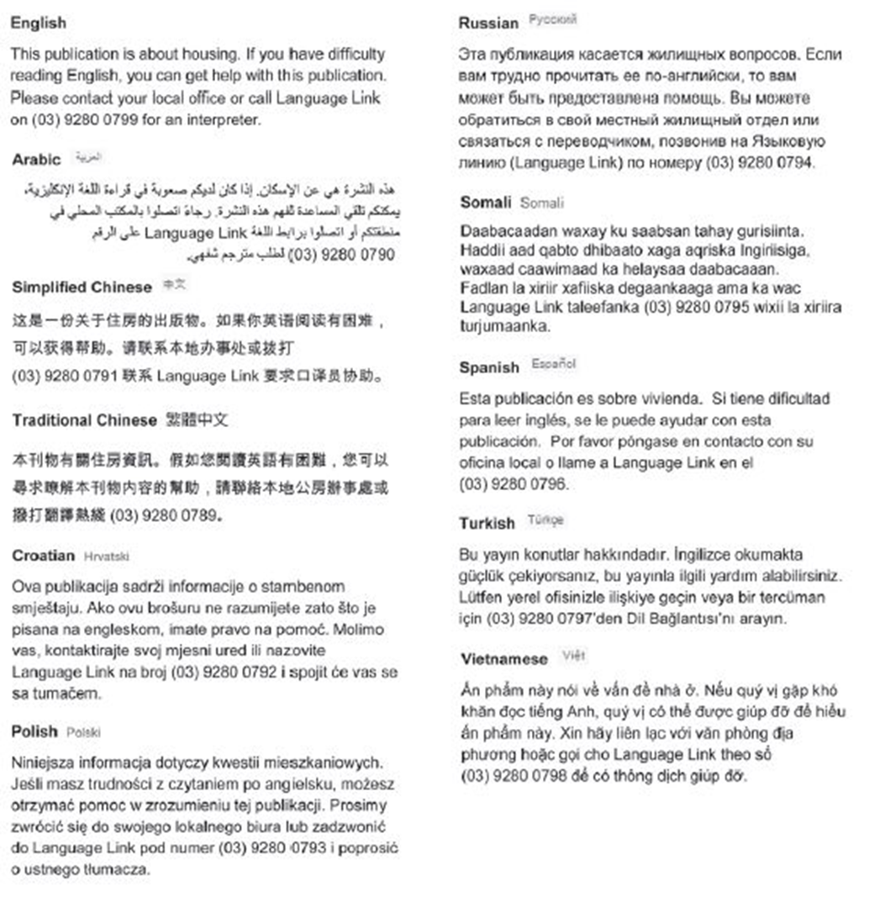

For other languages, an interpreter is available through your local office.