

|  |
| --- |
| Additional dependent children form |
|  |

# OFFICE USE ONLY

|  |  |
| --- | --- |
| Date received |  |
| Received by |  |
| Date registered |  |
| Service ID |  |
| Complete? (Yes or No) |  |

# Filling in this form

Use this form to tell us about up to four other dependent children that you want listed on your application for social housing.

If you need to add more children, you will need to use extra copies of this form.

If handwriting, use **black** or **blue** pen and write in **CAPITAL** letters.

# Need help or want this document in another format?

Go to [Housing.vic’s Apply for social housing page](http://housing.vic.gov.au/apply-social-housing) <http://housing.vic.gov.au/apply-social-housing> or contact your local Department of Health and Human Services office.

# Section A: Applicant’s details

In this section, we ask for the details of the person who is the owner (primary applicant) of the Victorian Housing Register application.

## Personal information

### Q1 Title

| Title | Mark with X |
| --- | --- |
| **Mr** |  |
| **Miss** |  |
| **Ms** |  |
| **Mrs** |  |
| **Dr** |  |
| **Prof** |  |
| **Other** |  |

| Other (please specify) |
| --- |
|  |

### Q2 First name

| ****First name**** |  |
| --- | --- |

### Q3 Middle name

| ****Middle name**** |  |
| --- | --- |

### Q4 Last name

| ****Last name**** |  |
| --- | --- |

### Q5 Date of birth

| Date of birth |  |
| --- | --- |

### Q6 Gender

| Gender | Mark with X |
| --- | --- |
| **Male** |  |
| **Female** |  |
| **Indeterminate** |  |
| **Intersex** |  |
| **Other** |  |

### Q7 Application number

| ****Application number**** |  |
| --- | --- |

### Q8 Telephone

| ****Telephone**** |  |
| --- | --- |

## Postal address

If you don't have a postal address, you can enter the postal address of a friend, relative or support worker.

### Q9 Street name and number

| ****Street name and number**** |  |
| --- | --- |

### Q10 Suburb or town and postcode

| ****Suburb or town**** |  |
| --- | --- |
| ****Postcode**** |  |

## Residential address

### Q11 Residential address

| Option | Mark with X |
| --- | --- |
| **Same as postal address** |  |
| **I don’t have a fixed address** |  |

### Q12 Street name and number

| ****Street name and number**** |  |
| --- | --- |

### Q13 Suburb or town and postcode

| ****Suburb or town**** |  |
| --- | --- |
| ****Postcode**** |  |

# Section B: Additional dependent children details

In this section, we ask for the details of all dependent children you want to add to your Victorian Housing Register application.

## Document icon Document required

You will need to give us a copy of a Medicare card, Health Care Card, or a birth certificate or extract to confirm the names of the children.

If you are requesting additional rooms for child access arrangements, we will also need documentation from a solicitor or the Family Law Court, or a statutory declaration from the primary caregiver to confirm the custody arrangements.

## Dependent child 1

### Q14 First name

| ****First name**** |  |
| --- | --- |

### Q15 Middle name

| ****Middle name**** |  |
| --- | --- |

### Q16 Last name

| ****Last name**** |  |
| --- | --- |

### Q17 Primary caregiver

| Primary caregiver |  |
| --- | --- |

### Q18 Date of birth

| Date of birth |  |
| --- | --- |

### Q19 Gender

| Gender | Mark with X |
| --- | --- |
| **Male** |  |
| **Female** |  |
| **Indeterminate** |  |
| **Intersex** |  |
| **Other** |  |

### Q20 Country of birth

| Option | Mark with X |
| --- | --- |
| **Australia** |  |
| **Other** |  |

| Other (please specify) |
| --- |
|  |

### Q21 Aboriginal status

| Options | Mark with X |
| --- | --- |
| **No** |  |
| **Aboriginal** |  |
| **Torres Strait Islander** |  |
| **Both** |  |

### Q22 Australian residency status

| Status | Mark with X |
| --- | --- |
| Australian citizen |  |
| Temporary Protection Visa |  |
| Sponsored migrant |  |
| Permanent resident |  |
| Protection Visa |  |
| New Zealand resident |  |
| Resolution of Status Visa |  |

| Visa subclass  (For Temporary Protection, Protection and Resolution of Status Visas) |
| --- |
|  |

### Q23 If they were born overseas, when did they start living in Australia

| If they were born overseas, when did they start living in Australia |  |
| --- | --- |

## Dependent child 2

### Q24 First name

| ****First name**** |  |
| --- | --- |

### Q25 Middle name

| ****Middle name**** |  |
| --- | --- |

### Q26 Last name

| ****Last name**** |  |
| --- | --- |

### Q27 Primary caregiver

| Primary caregiver |  |
| --- | --- |

### Q28 Date of birth

| Date of birth |  |
| --- | --- |

### Q29 Gender

| Gender | Mark with X |
| --- | --- |
| **Male** |  |
| **Female** |  |
| **Indeterminate** |  |
| **Intersex** |  |
| **Other** |  |

### Q30 Country of birth

| Option | Mark with X |
| --- | --- |
| **Australia** |  |
| **Other** |  |

| Other (please specify) |
| --- |
|  |

### Q31 Aboriginal status

| Options | Mark with X |
| --- | --- |
| **No** |  |
| **Aboriginal** |  |
| **Torres Strait Islander** |  |
| **Both** |  |

### Q32 Australian residency status

| Status | Mark with X |
| --- | --- |
| Australian citizen |  |
| Temporary Protection Visa |  |
| Sponsored migrant |  |
| Permanent resident |  |
| Protection Visa |  |
| New Zealand resident |  |
| Resolution of Status Visa |  |

| Visa subclass  (For Temporary Protection, Protection and Resolution of Status Visas) |
| --- |
|  |

### Q33 If they were born overseas, when did they start living in Australia

| If they were born overseas, when did they start living in Australia |  |
| --- | --- |

## Dependent child 3

### Q34 First name

| ****First name**** |  |
| --- | --- |

### Q35 Middle name

| ****Middle name**** |  |
| --- | --- |

### Q36 Last name

| ****Last name**** |  |
| --- | --- |

### Q37 Primary caregiver

| Primary caregiver |  |
| --- | --- |

### Q38 Date of birth

| Date of birth |  |
| --- | --- |

### Q39 Gender

| Gender | Mark with X |
| --- | --- |
| **Male** |  |
| **Female** |  |
| **Indeterminate** |  |
| **Intersex** |  |
| **Other** |  |

### Q40 Country of birth

| Option | Mark with X |
| --- | --- |
| **Australia** |  |
| **Other** |  |

| Other (please specify) |
| --- |
|  |

### Q41 Aboriginal status

| Options | Mark with X |
| --- | --- |
| **No** |  |
| **Aboriginal** |  |
| **Torres Strait Islander** |  |
| **Both** |  |

### Q42 Australian residency status

| Status | Mark with X |
| --- | --- |
| Australian citizen |  |
| Temporary Protection Visa |  |
| Sponsored migrant |  |
| Permanent resident |  |
| Protection Visa |  |
| New Zealand resident |  |
| Resolution of Status Visa |  |

| Visa subclass  (For Temporary Protection, Protection and Resolution of Status Visas) |
| --- |
|  |

### Q43 If they were born overseas, when did they start living in Australia

| If they were born overseas, when did they start living in Australia |  |
| --- | --- |

## Dependent child 4

### Q44 First name

| ****First name**** |  |
| --- | --- |

### Q45 Middle name

| ****Middle name**** |  |
| --- | --- |

### Q46 Last name

| ****Last name**** |  |
| --- | --- |

### Q47 Primary caregiver

| Primary caregiver |  |
| --- | --- |

### Q48 Date of birth

| Date of birth |  |
| --- | --- |

### Q49 Gender

| Gender | Mark with X |
| --- | --- |
| **Male** |  |
| **Female** |  |
| **Indeterminate** |  |
| **Intersex** |  |
| **Other** |  |

### Q50 Country of birth

| Option | Mark with X |
| --- | --- |
| **Australia** |  |
| **Other** |  |

| Other (please specify) |
| --- |
|  |

### Q51 Aboriginal status

| Options | Mark with X |
| --- | --- |
| **No** |  |
| **Aboriginal** |  |
| **Torres Strait Islander** |  |
| **Both** |  |

### Q52 Australian residency status

| Status | Mark with X |
| --- | --- |
| Australian citizen |  |
| Temporary Protection Visa |  |
| Sponsored migrant |  |
| Permanent resident |  |
| Protection Visa |  |
| New Zealand resident |  |
| Resolution of Status Visa |  |

| Visa subclass  (For Temporary Protection, Protection and Resolution of Status Visas) |
| --- |
|  |

### Q53 If they were born overseas, when did they start living in Australia

| If they were born overseas, when did they start living in Australia |  |
| --- | --- |

## Income and assets

If any of the children earn any income and own or part-own any assets (including real estate), list them in this table.

### Q54 Income and assets information

| Child's name | Income or asset type | Gross income (per week) or asset value ($) | If asset, can it be cashed in or sold?  (Write yes or no) |
| --- | --- | --- | --- |
|  |  |  |  |
|  |  |  |  |
|  |  |  |  |
|  |  |  |  |
|  |  |  |  |

# Section C: Declaration

This section is to be completed by the person who is the owner (primary applicant) of the Victorian Housing Register application.

I declare that all the information provided in this additional dependent children form is true and correct.

I acknowledge that I must advise the Department of Health and Human Services (the department) if my circumstances change, and update the department with any details that are relevant to my application.

**WARNING:** If you wilfully give information that is untrue in any particular in this application, you may be liable to penalties under section 40 of the Housing Act 1983 (Vic).

| By signing this form, I have: | Mark with X |
| --- | --- |
| Completed all parts of the form |  |
| Attached all relevant documents, indicated with a document icon:  Document icon |  |

| ****Full name**** |  |
| --- | --- |
| Signature | [Please sign by hand] |
| Date |  |

## Information privacy

The Department of Health and Human Services is committed to protecting the privacy of your personal information. Personal information is information which directly or indirectly identifies a person. We need to collect and handle your personal information in order to be able to process your application. All the information you give us will be handled in accordance with the Privacy and Data Protection Act 2014 and the Health Records Act 2001.

If you are using other department programs we may share some of your information with them to help us coordinate better services for you. We will not use your information for any other purpose other than those listed on these forms, to provide services to you, or without your consent, unless the law requires us to do so.

You can access your information through the Freedom of Information Act 1982 or through the Privacy and Data Protection Act 2014. For information about Freedom of Information requests, call 1300 475 170 or apply online at the [Freedom of Information website](http://www.foi.vic.gov.au) <http://www.foi.vic.gov.au**>**. For further information about privacy, call 1300 884 706 or [email the Complaints and Privacy unit](mailto:privacy@dhhs.vic.gov.au) <privacy@dhhs.vic.gov.au>.

## Information privacy

The Department of Health and Human Services is committed to protecting the privacy of your personal information. Personal information is information which directly or indirectly identifies a person. We need to collect and handle your personal information in order to be able to process your application. All the information you give us will be handled in accordance with the Privacy and Data Protection Act 2014 and the Health Records Act 2001.

If you are using other department programs we may share some of your information with them to help us coordinate better services for you. We will not use your information for any other purpose other than those listed on these forms, to provide services to you, or without your consent, unless the law requires us to do so.

You can access your information through the Freedom of Information Act 1982 or through the Privacy and Data Protection Act 2014. For information about Freedom of Information requests, call 1300 475 170 or apply online at the [Freedom of Information website](http://www.foi.vic.gov.au) <http://www.foi.vic.gov.au**>**. For further information about privacy, call 1300 884 706 or [email the Complaints and Privacy unit](mailto:privacy@dhhs.vic.gov.au) <privacy@dhhs.vic.gov.au>.

# Language Link

This publication is about housing. If you have difficulty reading English, you can get help with this publication. Please contact your local office or call Language Link on (03) 9280 0799.

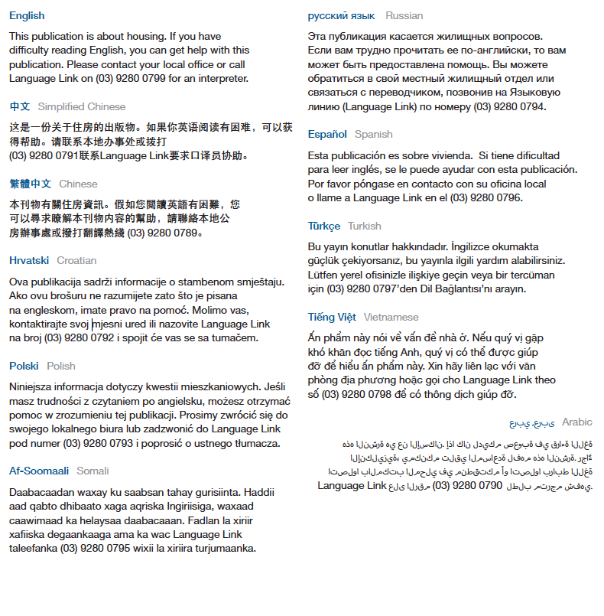

To receive this publication in an accessible format, phone 1300 475 170, using the National Relay Service (13 36 77) if required or [contact your local office](http://housing.vic.gov.au/contact-a-local-office) <http://www.housing.vic.gov.au/contact-a-housing-office>.

Authorised and published by the Victorian Government, 1 Treasury Place, Melbourne.

© State of Victoria, Department of Health and Human Services, January 2018.

Available at [Housing.vic's Apply for social housing page](http://www.housing.vic.gov.au/apply-social-housing) <http://www.housing.vic.gov.au/apply-social-housing>