

|  |
| --- |
| New Norlane project |
| Progress report – January 2018 |

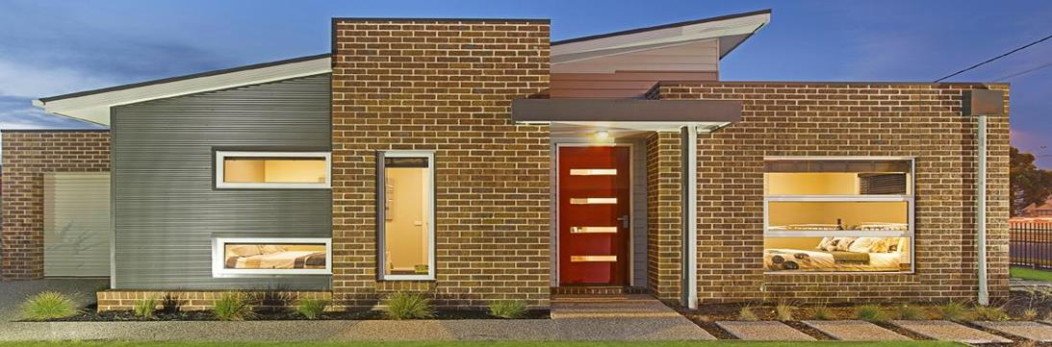

173 public housing homes and 169 affordable private homes

# Project background

* The New Norlane project was announced in 2012
* It is an $80 million investment into delivering 342 new homes on 200 vacant blocks of land
* The project has constructed 169 affordable private homes and 173 public housing homes
* The public housing homes will be indistinguishable from private homes
* The Geelong Work and Learning Centre is part of the revitalisation of the local community. It provides support to local residents through pathways to education, training and employment.

# Project progress

* The project aimed to help revitalise Norlane by increasing the availability of high-quality affordable housing, while generating employment opportunities and investment at the local level
* All 173 public housing homes were completed in September 2017
* 167 affordable private homes have been sold – two remain to be sold

# Project overview

**Location of project:**New Norlane, Geelong

**Project value:**$80 million investment

**Project delivery:**342 new homes

**Completion date:**March 2018

To receive this publication in an accessible format phone 03 9096 5685, using the National Relay Service 13 36 77 if required, or [email Lisa Taylor](mailto:lisa.taylor@dhhs.vic.gov.au) <lisa.taylor@dhhs.vic.gov.au>

Authorised and published by the Victorian Government, 1 Treasury Place, Melbourne.

© State of Victoria, Department of Health and Human Services, January 2018.

Available on the [Housing.vic Completed projects page](http://www.housing.vic.gov.au/completed-projects) <http://www.housing.vic.gov.au/completed-projects>