

|  |
| --- |
| Application for internal/external works permit |
|  |

# How to apply

You need written approval from the Department of Health and Human Services because the proposed change to your property must meet the department’s standards.

If you wish to install an **external** item, such as a garage or pergola, you will also need to contact your local council. Your council will inform you of the specific building requirements you must meet. You may also be required to pay for a building permit.

Complete this form and return it to your local office. If appropriate, include building permits, plans and other documentation from your local council.

If you need more information or assistance to complete this form, contact your local office.

# Application details

## Tenant details

|  |  |
| --- | --- |
| Tenant name | <Fill in tenant names> |
| Property address | <Fill in property address> |
| Local office | <Fill in local office> |
| Date of application | <Fill in date of application> |

## Builder details – if needed

If a qualified builder is to install the item, please give details of the builder.

|  |  |
| --- | --- |
| Name of builder | <Fill in the name of builder> |
| Address | <Fill in address of builder> |
| Registration number | <Fill in registration number> |
| Telephone | <Fill in telephone number> |

## Installation company details – if needed

If an installation company is to fit the item, please give details of the company:

|  |  |
| --- | --- |
| Name of company | <Fill in name of the company> |
| Address | <Fill in the company address> |
| Telephone | <Fill in the company telephone number> |

# Proposed change

**Please note:**

* external window-mounted air conditioners in multi-storey properties are not permitted
  + swimming pools and spas are not permitted.

**Please attach** any extra details or information to this application:

* plans or drawings are required showing site location, measurements, and so on
* a copy of the building permit may be required
  + any other information that may be needed.

## External works

Select the appropriate item to be included in your property and give details as needed:

|  |  |
| --- | --- |
| External work item | Item to be included?  Mark with an X and add any details |
| Garage |  |
| Bungalow or Sleep out |  |
| Carport |  |
| Enclosed rear or front porch |  |
| Pergola |  |
| External awnings |  |
| Pergola |  |
| External awnings |  |
| Garden shed |  |
| Communication equipment |  |
| PV or Solar equipment |  |
| TV antennas, satellite dishes, cable TV connections |  |
| Other |  |

## Internal works

Select the appropriate item to be included in your property and give details as needed:

|  |  |  |
| --- | --- | --- |
| Internal work item | Item to be included?  **Mark with an X** | Details |
| **Appliances** (such as air conditioners, dishwashers, rangehoods or heaters) |  | Specify appliance and location: |
| **Floor coverings** (such as carpets, sheet vinyl or ceramic tiles) |  | Specify type and location: |
| **Internal painting** (light or pastel colours only) |  | Specify location: |
| **Built-in robes** |  | Specify location: |
| **Electrical** (such as power points or light fittings) |  | Specify details and location: |
| **Other** |  | Specify details: |

## Council permit

|  |  |
| --- | --- |
| Is a council building permit required for this work? | <yes or no> |
| Has the council permit been issued? | <yes or no> |

If council permit has been issued, **attach a copy of the permit to this application**.

# Internal/external works permit conditions

1. The Director of Housing (the Director) and their representatives are not involved in any expense for the inclusion of the item or items listed in this application form. The tenant must not commence the works before their local office advises them that the Director has approved the works in writing.
2. The work is to be carried out by a qualified tradesperson, or in a trade-like manner, without damage to the property. If the property is damaged, the tenant will be responsible for the cost of repairs.
3. If a permit is required for the works from the local council, the tenant must get that approval at their own expense. The works must not commence before the permit is given. The works will be subject to inspection by the local office. The tenant is to contact their local office when the works are finished. If the council has issued a permit for the works, the tenant must get a final inspection notice and give that to the local office.
4. The item/s listed in this application form is/are to be maintained at the tenant’s expense and insured by the tenant.
5. The work carried out must comply with all laws and be relevant to Australian standards and industry standards.
6. Prior to the tenant vacating the premises, an inspection of the property is carried out by the local office to determine one or more of the following:
   * + 1. The item/s listed in this permit application form will become the property of the Director without reimbursement to the tenant should the tenant vacate without removing the item/s listed in this permit,
       2. The tenant will meet the cost of restoring the property to its original condition in the event of vacating the property and removing the item/s. This may include any redecorating that may take place,
       3. The tenant will meet the cost of restoring the property to its original condition by the Director and his/her representatives in the event that the tenant vacates the property and leaves the item/s at the property, and the Director takes action to remove the item/s. This includes any redecorating that may take place. If the tenant does not remove the item/s and refuses to pay for restoration works deemed necessary by the Director and his/her representatives, the Director may make an application to the Victorian Civil and Administrative Tribunal to seek compensation for costs associated with the restoration works.
7. Any item in the property that is replaced such as gas stove and heater, must be delivered to the address instructed by the local office and must not be traded in.
8. TV antennas can only be fixed to brick and concrete chimneys with approved brackets to the manufacturer’s specifications.
9. Each application will be assessed on its own merit and without bias. However, the Director reserves the right to refuse any application deemed to be inappropriate.

# Declaration to be signed by all tenants

I/we have read and agree to the permit conditions on this application.

I/we declare that all the information requested in this application for an internal/external works permit has been provided and is true and correct.

## Declared by

|  |  |
| --- | --- |
| Full name of tenant | <Fill in full name of tenant making the declaration> |
| Signature | <Signature of tenant making the declaration> |

### Witnessed before

|  |  |
| --- | --- |
| Full name of witness | <Fill in the full name of the witness> |
| Signature | <Signature of the witness> |
| Date | <Fill in the date> |

## Declared by

|  |  |
| --- | --- |
| Full name of tenant | <Fill in additional tenant’s full name> |
| Signature | <Signature of additional tenant> |

### Witnessed before

|  |  |
| --- | --- |
| Full name of witness | <Fill in the full name of the witness> |
| Signature | <Signature of the witness> |
| Date | <Fill in the date> |

To receive this publication in an accessible format, call 1300 475 170, using the National Relay Service (13 36 77) if required.

Authorised and published by the Victorian Government, 1 Treasury Place, Melbourne.   
© State of Victoria, September 2017.

ISBN 978-1-76069-009-0

Available on the Housing website’s [Making alterations to your home page](http://www.housing.vic.gov.au/making-alterations-your-home)  
<http://www.housing.vic.gov.au/making-alterations-your-home>

# OFFICE USE ONLY

## Permit endorsed by field services officer (FSO)

|  |  |
| --- | --- |
| Signature | <Signature of FSO> |
| Date | <Fill in the date> |

## Council permit

|  |  |
| --- | --- |
| Status | Mark with an x |
| Attached |  |
| Not attached |  |
| Not applicable |  |

## Application

|  |  |
| --- | --- |
| Status | Mark with an x |
| Approved |  |
| Not approved |  |

## Manager, Tenancy and Property

|  |  |
| --- | --- |
| Signature | <Signature of manager> |
| Date | <Fill in the date> |

# LanguageLink

This publication is about housing. If you have difficulty reading English, you can get help with this publication. Please contact your local office or call Language Link on (03) 9328 0799 for an interpreter.

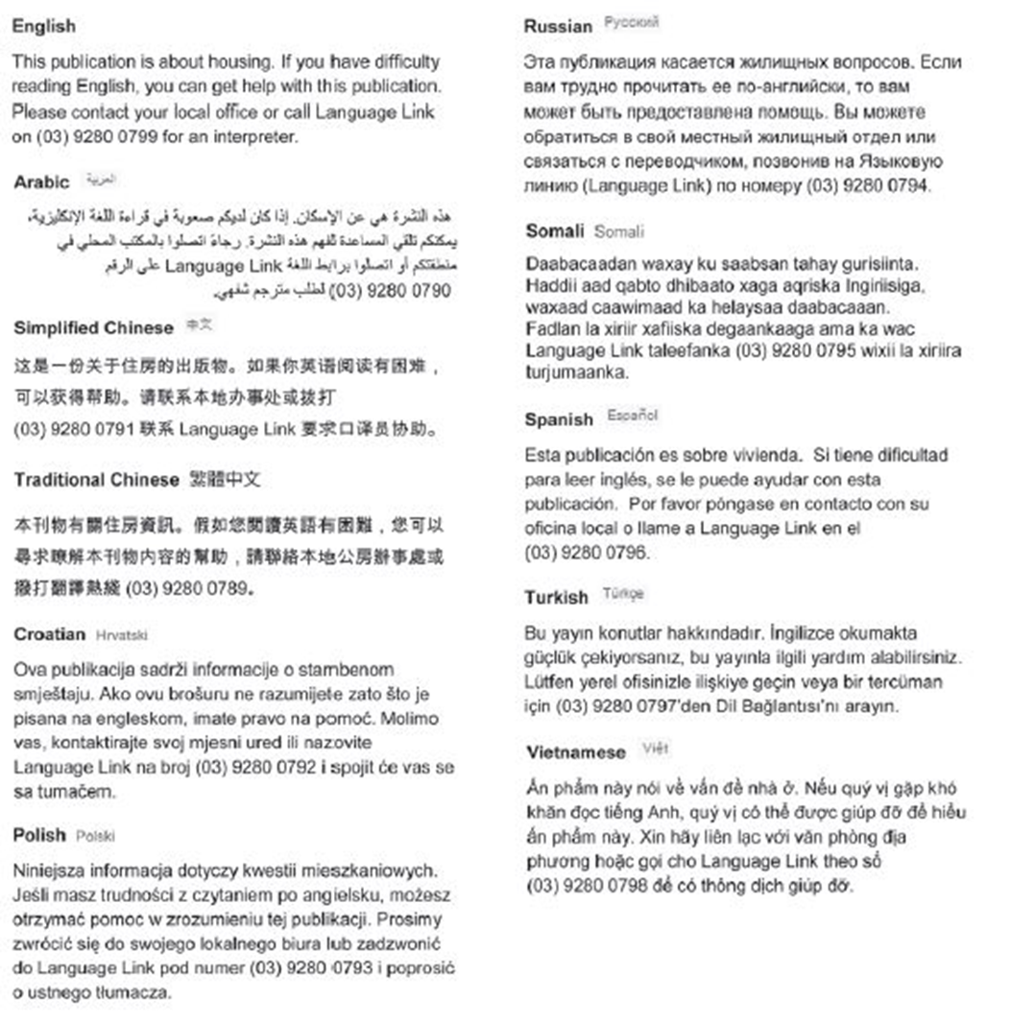

**For other languages, an interpreter is available through your local office.**