

|  |
| --- |
| Additional adult household member form |
|  |

# OFFICE USE ONLY

|  |  |
| --- | --- |
| Date received |  |
| Received by |  |
| Date registered |  |
| Service ID |  |
| Complete? (Yes or No) |  |

# Filling in this form

Use this form to tell us about one other adult that you want listed on your application for social housing.

If you need to add more people, you will need to use extra copies of this form.

If handwriting, use **black** or **blue** pen and write in **CAPITAL** letters.

# Need help?

Need help or want this document in another format?

Go to [Housing.vic’s Apply for social housing page](http://housing.vic.gov.au/apply-social-housing) <http://housing.vic.gov.au/apply-social-housing> or contact your local Department of Health and Human Services office.

# Section A: Applicant’s details

In this section, we ask for the details of the person who is the owner (primary applicant) of the Victorian Housing Register application.

## Personal information

### Q1 Title

| Title | Mark with X |
| --- | --- |
| **Mr** |  |
| **Miss** |  |
| **Ms** |  |
| **Mrs** |  |
| **Dr** |  |
| **Prof** |  |
| **Other** |  |

| Other (please specify) |
| --- |
|  |

### Q2 First name

| First name |  |
| --- | --- |

### Q3 Middle name

| Middle name |  |
| --- | --- |

### Q4 Last name

| Last name |  |
| --- | --- |

### Q5 Date of birth

| Date of birth |  |
| --- | --- |

### Q6 Gender

| Gender | Mark with X |
| --- | --- |
| **Male** |  |
| **Female** |  |
| **Indeterminate** |  |
| **Intersex** |  |
| **Other** |  |

### Q7 Application number

| ****Application number**** |  |
| --- | --- |

### Q8 Telephone

| ****Telephone**** |  |
| --- | --- |

## Postal address

If you don't have a postal address, you can enter the postal address of a friend, relative or support worker.

### Q9 Street name and number

| ****Street name and number**** |  |
| --- | --- |

### Q10 Suburb or town and postcode

| ****Suburb or town**** |  |
| --- | --- |
| ****Postcode**** |  |

## Residential address

### Q11 Residential address

| Option | Mark with X |
| --- | --- |
| **Same as postal address** |  |
| **I don’t have a fixed address** |  |

### Q12 Street name and number

| ****Street name and number**** |  |
| --- | --- |

### Q13 Suburb or town and postcode

| ****Suburb or town**** |  |
| --- | --- |
| ****Postcode**** |  |

# Section B: Additional adult household member

In this section, we ask for the details of the additional adult household member you want to add to your Victorian Housing Register Application.

## Personal Information

### Q14 Title

| Title | Mark with X |
| --- | --- |
| **Mr** |  |
| **Miss** |  |
| **Ms** |  |
| **Mrs** |  |
| **Dr** |  |
| **Prof** |  |
| **Other** |  |

| Other (please specify) |
| --- |
|  |

### Q15 First name

| ****First name**** |  |
| --- | --- |

### Q16 Middle name

| ****Middle name**** |  |
| --- | --- |

### Q17 Last name

For example: name at birth, maiden name, previous married name, alias.

| ****Last name**** |  |
| --- | --- |

### Q18 Preferred name (if any)

| Preferred name |  |
| --- | --- |

### Q19 Previous name (if any)

| Previous name |  |
| --- | --- |

### Q20 Date of birth

| Date of birth |  |
| --- | --- |

### Q21 Gender

| Gender | Mark with X |
| --- | --- |
| **Male** |  |
| **Female** |  |
| **Indeterminate** |  |
| **Intersex** |  |
| **Other** |  |

### Q22 Relationship status

| Option | Mark with X |
| --- | --- |
| **Single** |  |
| **Partnered** |  |

| If you have a partner, partner’s name |
| --- |
|  |

### Q23 Aboriginal status

| Options | Mark with X |
| --- | --- |
| **No** |  |
| **Aboriginal** |  |
| **Torres Strait Islander** |  |
| **Both** |  |

### Q24 Country of birth

| Option | Mark with X |
| --- | --- |
| **Australia** |  |
| **Other** |  |

| If other, please specify |
| --- |
|  |

### Q25 Are they expecting a child?

We need this information so we can work out how many bedrooms are needed.

| Option | Mark with X |
| --- | --- |
| **No** |  |
| **Yes** |  |

| If yes, due or arrival date |
| --- |
|  |

#### Document icon Document required

**Provide a letter from a doctor confirming when the baby is due**, or from the person or organisation that is arranging the adoption or permanent care to confirm when the child will be in their care.

### Q26 Australian residency status

| Status | Mark with X |
| --- | --- |
| Australian citizen: go to **Q29** |  |
| Temporary Protection Visa |  |
| Sponsored migrant |  |
| Permanent resident |  |
| Protection Visa |  |
| New Zealand resident |  |
| Resolution of Status Visa |  |

| Visa Subclass  (for Temporary Protection, Protection and Resolution of Status Visas) |
| --- |
|  |

### Q27 Date of arrival in Australia

| Date of arrival in Australia |  |
| --- | --- |

### Q28 Are they affected by Centrelink’s two-year newly arrived residents waiting period?

The expiry date is two years from your arrival date to Australia.

| Option | Mark with X |
| --- | --- |
| **No** |  |
| **Yes** |  |

| Yes – ****Expiry date**** |
| --- |
|  |

## Centrelink Confirmation eServices

### Alert exclamation mark icon Important!

If they receive a Centrelink payment and agree to use Centrelink Confirmation eServices, **you will not need to tell us about their income or assets**.

It will **save you time** and you may get a **faster response** to your application.

### Q29 Do they agree to use Centrelink Confirmation eServices?

| Option | Mark with X |
| --- | --- |
| **No, go to** **Q36** |  |
| **Yes**, **ask the household member to read and sign the following** |  |

### Consent to use Centrelink Confirmation eServices

I authorise the Australian Government Department of Human Services (Centrelink) to provide the Victorian Department of Health and Human Services (the department) with the results of the enquiries I have indicated below in order to enable the department to determine if I qualify for social housing services.

I understand that the information provided by Centrelink to the department may contain the following:

* **income confirmation –**  personal information such as (but not limited to) current or historical details of Centrelink payments received, dependants, marital or partnered status, Centrelink deductions, income from sources other than Centrelink and assets
  + **contact and address verification – my** current address and contact details, and also my address history (up to two years), which the department may use to support a Priority Access application.

I authorise the department to use Centrelink Confirmation eServices to perform a Centrelink enquiry of my Centrelink income, asset and payment details.

I understand this consent, once signed, remains valid while I am a customer of the department, unless I revoke it by contacting the department or Centrelink.

I understand that if I withdraw my consent or do not alternatively provide proof of my circumstances/details, I may not be eligible for the service provided by the department.

### Q30 I consent to using the following:

| I consent to using | Mark with X |
| --- | --- |
| Both (recommended) |  |
| Only income confirmation |  |
| Only contact and address verification |  |

### Q31 Full name

| ****Full name**** |  |
| --- | --- |

### Q32 Street name and number

| ****Street name and number**** |  |
| --- | --- |

### Q33 Suburb or town and postcode

| ****Suburb or town**** |  |
| --- | --- |
| ****Postcode**** |  |

### ****Q34 Centrelink Reference Number (CRN) and date of birth****

| ****Centrelink Reference Number**** |  |
| --- | --- |
| ****Date of birth**** |  |

### Q35 Signature and today’s date

| Signature | [Please sign by hand] |
| --- | --- |
| Today’s date |  |

## Income and assets

 If the household member **agreed to use Centrelink Confirmation eServices**, do **not** fill out this section.

Go to **Section C (Declaration)****.**

### Document icon Document required

For household members who are **not** Centrelink customers, we will need 100 points of identification.

For accepted documents that can make up 100 points, refer to the *Proof of Identity factsheet* which you should have received with this application. If you don’t have it, you can get it from the [Housing.vic's Social housing page](http://housing.vic.gov.au/social-housing) <http://housing.vic.gov.au/social-housing> or by contacting one of our offices.

### Q36 Centrelink Reference Number (CRN)

| Centrelink Reference Number (CRN) |  |
| --- | --- |

### Q37 Department of Veterans Affairs (DVA) number

| Department of Veterans Affairs number |  |
| --- | --- |

## Income details

This could include Centrelink payments, wages, self-employed income, Veterans’ Affairs or compensation payments.

### Q38 Income type and gross income

| Income type | Gross income (per week) ($) |
| --- | --- |
|  |  |
|  |  |
|  |  |

#### Document icon Document required – Proof of income

If you receive an income from Centrelink or the Department of Veterans’ Affairs (DVA), you will need to give us an income and asset statement that is less than two weeks old.

If you have a paying job, you will need to give us a pay slip or a wage statement signed by your employer. It needs to show your wages before tax for the past 13 weeks.

If you are self-employed, please have an accountant complete a profit and loss statement for the last 13 weeks.

## Real estate details

### Q39 Do they own or part-own any real estate or land?

| Options | Mark with X |
| --- | --- |
| **No**, **go to** **Asset Details** |  |
| **Yes**, continue |  |

#### Document icon Document required

We will need a letter from an approved valuer or solicitor stating their property’s market value and their equity in it. If they part-own the property, we need information that details their share. If the property is held in trust, we need a letter from the executor of the estate.

### Q40 Real estate or land value

| Real estate or land value |  |
| --- | --- |

### Q41 Street name and number

| ****Street name and number**** |  |
| --- | --- |

### Q42 Suburb or town and postcode

| ****Suburb or town**** |  |
| --- | --- |
| ****Postcode**** |  |

### Q43 Are they able to live in the property permanently?

| Option | Mark with X |
| --- | --- |
| **No** |  |
| **Yes** |  |

#### Document icon Document required

If they are unable to live in the property permanently, we need documents that explain why.

### Q44 Can this real estate or land be sold?

| Option | Mark with X |
| --- | --- |
| **No** |  |
| **Yes** |  |

### Is the property for sale?

| Option | Mark with X |
| --- | --- |
| **No** |  |
| **Yes** |  |

#### Document icon Document required

If the property is for sale, we need a document from the real estate agent confirming this.

### Q45 If you answered No to any of these questions, tell us why

| If you answered No to any of these questions, tell us why: |
| --- |
|  |

### Q46 Is the property subject to a dispute or an application for settlement in the Family Court?

| Option | Mark with X |
| --- | --- |
| **No** |  |
| **Yes** |  |

| If yes – what is the reason |
| --- |
|  |

#### Document icon Document required

If there is a dispute or application for settlement, we need a document from their solicitor including details of ownership.

## Asset details

An asset is something you own that can be turned into money — like shares, businesses, mobile homes and any cash you have in the bank. In addition to their assets, if they are expecting to receive a payout from an organisation like WorkSafe or the Transport Accident Commission (TAC), please list it here.

### Q47 Asset information

| Asset type | Value ($) | Can the asset be cashed in or sold?  (Write yes or no) |
| --- | --- | --- |
|  |  |  |
|  |  |  |
|  |  |  |
|  |  |  |
|  |  |  |

#### Document icon Document required – Proof of assets

If you or a household member are receiving payments from Centrelink, we will get your asset information from your Centrelink statement.

For each person who does not receive a payment from Centrelink, we will need:

* + - * + a copy of your bank book or a bank statement that is not more than four weeks old – an automated teller machine (ATM) statement is allowed as long as it shows the name of the account holder
        + documents stating the value of any other assets you own or have an interest in.

# Section C: Declaration

This section is to be completed by the person who is the owner (primary applicant) of the Victorian Housing Register application.

I declare that all the information provided in this additional adult household member form is true and correct.

I acknowledge that I must advise the Department of Health and Human Services (the department) if my circumstances change, and update the department with any details that are relevant to my application.

**WARNING:** If you wilfully give information that is untrue in any particular in this application, you may be liable to penalties under section 40 of the Housing Act 1983 (Vic).

| By signing this form, I have: | Mark with X |
| --- | --- |
| Completed all parts of the form |  |
| Attached all relevant documents, indicated with a document icon:  Document icon |  |

| ****Full name**** |  |
| --- | --- |
| Signature | [Please sign by hand] |
| Date |  |

## Information privacy

The Department of Health and Human Services is committed to protecting the privacy of your personal information. Personal information is information which directly or indirectly identifies a person. We need to collect and handle your personal information in order to be able to process your application. All the information you give us will be handled in accordance with the Privacy and Data Protection Act 2014 and the Health Records Act 2001.

If you are using other department programs we may share some of your information with them to help us coordinate better services for you. We will not use your information for any other purpose other than those listed on these forms, to provide services to you, or without your consent, unless the law requires us to do so.

You can access your information through the Freedom of Information Act 1982 or through the Privacy and Data Protection Act 2014. For information about Freedom of Information requests, call 1300 475 170 or apply online at the [Freedom of Information website](http://www.foi.vic.gov.au) <http://www.foi.vic.gov.au**>**. For further information about privacy, call 1300 884 706 or [email the Complaints and Privacy unit](mailto:privacy@dhhs.vic.gov.au) <privacy@dhhs.vic.gov.au>.

# Language Link

This publication is about housing. If you have difficulty reading English, you can get help with this publication. Please contact your local office or call Language Link on (03) 9280 0799.

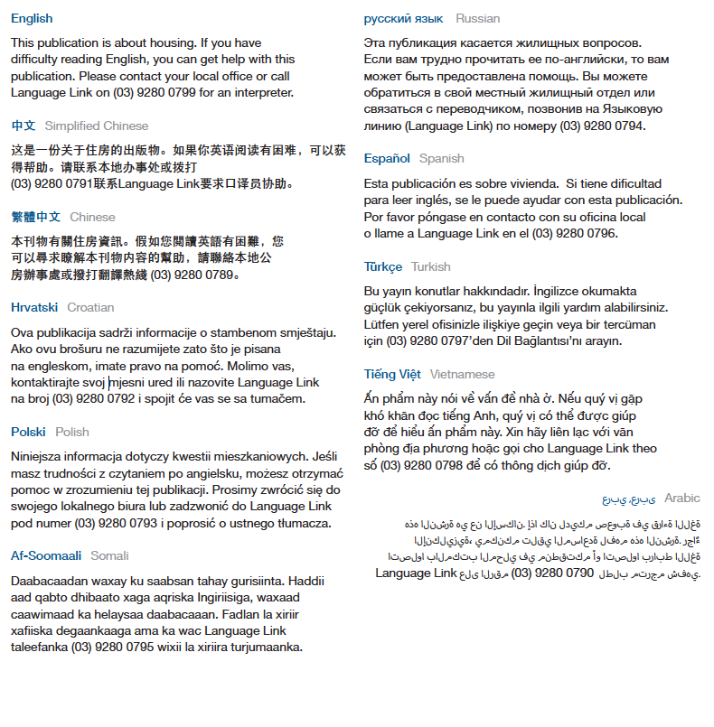

For other languages, an interpreter is available through your local office.

To receive this publication in an accessible format, phone 1300 475 170, using the National Relay Service (13 36 77) if required or [contact your local office](http://housing.vic.gov.au/contact-a-local-office) <http://www.housing.vic.gov.au/contact-a-housing-office>.

Authorised and published by the Victorian Government, 1 Treasury Place, Melbourne.

© State of Victoria, Department of Health and Human Services, January 2018.

Available at [Housing.vic's Apply for social housing page](http://www.housing.vic.gov.au/apply-social-housing) <http://www.housing.vic.gov.au/apply-social-housing>